IEEE BHI - BSN 2021

July 27th , 2021 – Online 16:10 – 19:00 CEST (virtual room 4)

WORKSHOP ON INTEGRATING GENDER PERSPECTIVE IN SCIENCE, TECHNOLOGY, AND INNOVATION
Workshop description
This workshop will address the challenge to integrate the gender perspective in science, technology, and innovation (STI) in international cooperation and work towards gender equality. Despite the efforts in recent year, the EU and many other countries around the world have not yet reached the halfway mark to full gender equality, and women remain underrepresented in all fields of STI. Furthermore, gender equality in STI has become a strategic issue in the EU policy dialogues with third countries. This workshop brings together women from countries that have a long-standing tradition and history of cooperation with Europe in the area of STI (Canada, the United States of America, Mexico, Spain, South Africa, India) leveraging on their knowledge, diversity, policy dialogues background and gender expertise to discuss about a strategy to promote equality in scientific careers, gender balance in decision making and the integration of the gender dimension in R&I content.

Organisers:
María F. Cabrera-Umpiérrez Yolanda Ursa
Universidad Politécnica de Madrid INMARK
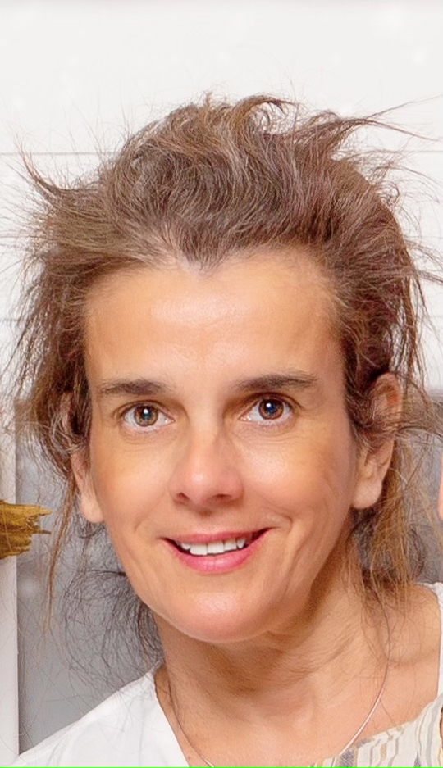

Program

15:40 – 16:00 Presentation of the Workshop. The GENDER-STI initiative. María F Cabrera (Universidad Politecnica de Madrid) and Yolanda Ursa (INMARK).
16:00 – 16:10 Gender balance in decision making. Surbhi Sharma. Euro India Research Centre. India.
16:10 – 16:20 The case of TEC de Monterrey: Gender perspective in the Institution and in Research. Isabel Kreiner. Instituto Tecnológico y de Estudios Superiores de Monterrey. Mexico.
16:20 – 16:40 Gender in STI - A South African perspective. Marlien Herselman. Council for Scientific and Industrial Research. South Africa.
16:40 – 16:55 Panel discussion.
16:55 – 17:00 Break
17:00 – 17:15 Gender equality in scientific careers. Holly Jimison. Northeastern University. USA.
17:15 – 17:30 Integration of the gender dimension in research and innovation content. Maria Teresa Arredondo. Universidad Politecnica de Madrid. Spain.
17:30 – 18:00 Open discussion IEEE-EMBS BHI and BSN for promoting and addressing gender equality in science, technology, and innovation.
18:00 – 18:15 Closing remarks.

